Flowchart and Notes Three

Michael Surdek
Southern New Hampshire University
DAT 690: Capstone in Data Analytics
Professor Arman Kanooni
October 9, 2022
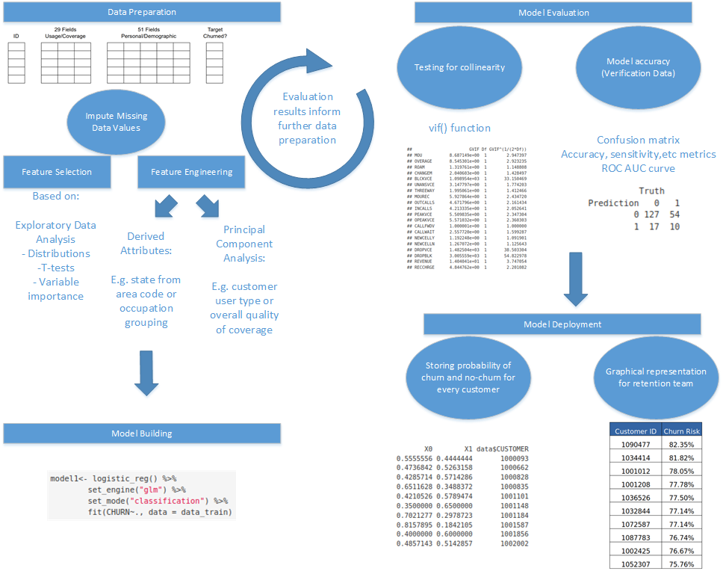
This is a combination of my first 2 flowcharts with some added steps and details. It breaks down the steps within the CRISP-DM process phases between data preparation and model deployment. First, the initial data preparation involves handling missing data and then proceeds to generating model inputs through feature selection, derived attributes, and dimensionality reduction. Then the model can be trained and tested further. We now have the verification data file for testing the model’s performance on unseen data. Important aspects of model evaluation are testing for collinearity and assessing performance metrics such as accuracy, recall, precision, ROC AUC, etc. The final phase of the CRISP-DM process is model deployment, where the model’s output is rolled out to business users. In this case, a table can be created for the customer retention team that highlights the customers with the highest likelihood of churn. Additionally, customer contact information can be provided so that the customer retention team can reach out proactively and hopefully save the customer’s business.

